OPERATING PLAN

Customer Experience Plan

Transit Systems NSW

**Last updated:** June 2023

Table of Contents

1 INTRODUCTION 5

1.1 Background 5

1.2 Scope 5

2 Objectives 5

3 Our customer service model 6

3.1 Customer Charter 6

3.2 Company Values 8

3.3 Staff competency – Customer service training and development of staff 10

3.4 Roles and Responsibilities 10

4 Customer communication and interfaces throughout the journey during normal, degraded and planned service disruption operations 12

4.1 Customer Communications Channels 12

4.1.1 Online Channels 12

4.1.2 At stop channels 12

4.1.3 On bus channels 12

4.2 Disruption messaging 12

4.2.1 Planned disruptions and special events 13

4.2.2 Day of operation disruptions (unplanned disruptions) 14

5 Customer and Staff safety and security 15

5.1 Safety Management System and Accreditations 16

5.2 Onboard safety and security systems 17

5.3 Safety and Security Reporting Mechanisms 17

6 Event Services Support 18

7 Ticketing, revenue protection and mitigation of fare evasion 19

8 Operational integration with other public transport services 19

9 Customer feedback and lost property management 20

9.1 Customer Feedback Management 20

9.2 Lost Property Management 21

10 Customer Service Training and Development of staff 23

10.1 Online Training Module – Customer Service (Including Disability Awareness) 23

10.2 Brilliant Customer Service Program 23

10.3 Classroom Induction Training 24

10.4 Driver Guidelines Handbook 24

10.5 Customer Service Campaigns and Messaging 25

10.6 Cultural Competency Training 25

10.7 Other Initiatives 25

11 Measures and strategies 26

12 Equitable access for all customers 26

# INTRODUCTION

## Background

Transit Systems is committed to providing high quality, customer focused public transport services that are convenient, accessible and reflect customer demand.

This document is designed to sit below the Communications and Marketing Plan and the Stakeholder Engagement Plan. This plan focuses on the operational elements required to deliver brilliant customer service and is supported by the Transit Systems NSW Customer Charter.

## Scope

This plan outlines how Transit Systems NSW will maintain and comply with the customer service requirements in our operating contracts. It outlines the strategies and initiatives that will be put in place to deliver brilliant customer service.

This strategy scope covers at a high level, major inputs including:

* Our customer service model
* Customer communication channels and interfaces
* Customer and staff safety and security
* Event services support
* Ticketing, revenue and mitigation of fare evasion
* Operational integration with other public transport services
* Customer feedback and lost property management
* Customer service training and development of staff
* Measures and strategies to ensure customer engagement in maintaining high standards and the continuous improvement of service delivery.
* Equitable access of information and services for customers

The timeframe in scope for this plan is the **2023/2024 Contract Year** with a review at its completion.

This plan will need to be reviewed and updated as needed, with compliance reported on a quarterly basis to Transport for NSW in its Quarterly Customer Experience Plan Reports.

Each year, we will build on our customer service capability and programs in partnership with TfNSW.

# Objectives

This plan aims to deliver on the following objectives:

* Increase safety across our workforce and implement safety systems to ensure safety is a priority in everything we do.
* Be a valued Operator and team player in the wider NSW transport network and make decisions that are in the best interests of the customer and the broader transport network.
* Exceed our KPIs relating to Customer Satisfaction through the implementation of proactive strategies to reduce complaints.
* Reduce customer complaints and increase customer commendations.
* Work with TfNSW to improve customer experience and information channels including the transportnsw.info website and TripPlanner, real-time apps, and lost property system and procedures.
* Reduce the level of fare evasion on our services through revenue protection strategies and education.
* Ensure access to our information and services are equitable for all.

# Our customer service model

At Transit Systems NSW, we focus on delivering a brilliant experience for every customer. This means exceeding our customer’s expectations at every step of the customer journey by:

* Treating others the way we expect to be treated
* Sharing our knowledge and providing assistance where possible
* Respecting and welcoming the diversity of our customers and their viewpoints, and treating everyone with respect
* Striving to make our customers feel valued so they become return customers.
* Listening to, anticipating, and responding to our customer’s needs.

Our Customer Charter and our company Values have been developed to ensure we always keep the customer at the centre of everything we do and guide us to ensure continuous improvement in the customer service we deliver.

## Customer Charter

Our Customer Charter sets out what the customer can expect from us when they travel on our bus services or deal with us as a business.

Our Customer Charter is supported by six Customer Principles which describe our objectives for providing a brilliant customer experience. These are:

* Safe and reliable
* Seamless and easy to use
* Engage and collaborate
* Continuous improvement
* Sustainable solutions
* Ongoing training

Our Customer Principles are further supported by our nine Customer Experience Drivers which help us deliver on our Customer Principles and define our objectives around our customer experience. These Customer Experience Drivers have been designed to deliver against Transport for NSW’s nine customer satisfaction drivers, as specified in the Customer Satisfaction Survey. These consist of: Safety, Connected, Customer Service, Information, Cleanliness, Accessibility, Timeliness and Ticketing.



Our Customer Experience Drivers are incorporated into our operational documentation, processes, and measures of performance, to ensure that achieving customer satisfaction is always front of mind. This strong customer focus keeps us on track to deliver continuous improvement across the business and meet or exceed our key performance indicators.

## Company Values

Our Company Values are our guiding principles which support and shape the way we do business. They embody our culture and help create an environment where we fundamentally share the same morals and behaviours, to ensure we always conduct ourselves and our business to the highest standards and with integrity, from our leadership team to our frontline.

Our values are based around the word COMPASS, and we chose this word as the backbone of our values due to its connotations of guidance and direction. Like the compass shows the magnetic north and bearings from it, our COMPASS Values show us the principles and behaviours that will help create an inclusive and supportive culture where everyone feels appreciated, respected, and enjoys their workplace, and that these feelings are carried over to our service delivery.

COMPASS stands for:

* Customer Brilliance
* One Team
* Motivated
* Professional
* Authentic
* Successful
* Safety

These values underpin our company with the solid foundations we need to ensure our continued success.

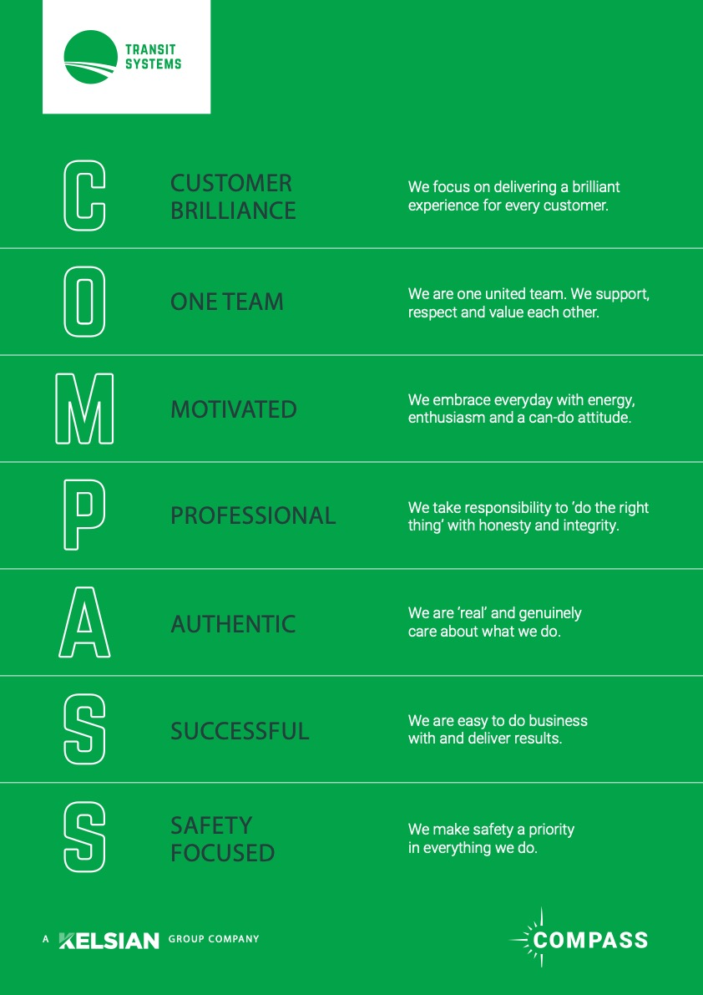

## Staff competency – Customer service training and development of staff

From the mechanics who ensure our fleet runs smoothly, to our drivers, operational support employees and the leadership team, all employees are required to undertake our customer service training to ensure we continue to provide brilliant customer service.

Our customer service training is delivered across a variety of channels and is complemented by regular internal communications campaigns and material reinforcing our expectations, associated behaviours, and company values.

We understand that the job of operating contract bus regions for Transport for NSW is bigger than just operating a bus service. We ensure our team is equipped with the tools and training to provide exceptional service, understanding, and sensitivity under any circumstance.

Our strategy for Customer Service training and development of staff is outlined in Section 10 of this document – Customer Service Training and Development of Staff.

## Roles and Responsibilities

Our organisational structure has been designed to ensure there is a strong focus on customer service. To support our operational team, we have a dedicated NSW Customer Experience and Communications team which is responsible for:

* Communicating with our customers
* Communicating with our staff
* Issues management, complaint resolution, and correspondence
* Oversight and responsibility of the Customer Feedback Management systems and reporting
* Managing our Mystery Shopper program
* Identifying customer feedback trends and communicating these to the broader business

A Customer Experience Officer is also dedicated to each depot, working together with depot management and support staff to ensure any customer complaints are fully investigated, responded to, and that appropriate actions are taken to fix the root cause of the issue.

The 24/7 Operations Control Centre and team of On Road Coordinators, also work with the Customer Experience and Communications team to communicate any service disruptions, both planned and unplanned, to both the Transport Management Centre and to customers directly, to ensure they can plan their journey with confidence.

The below diagram details the structure of our Customer Experience and Communications team.

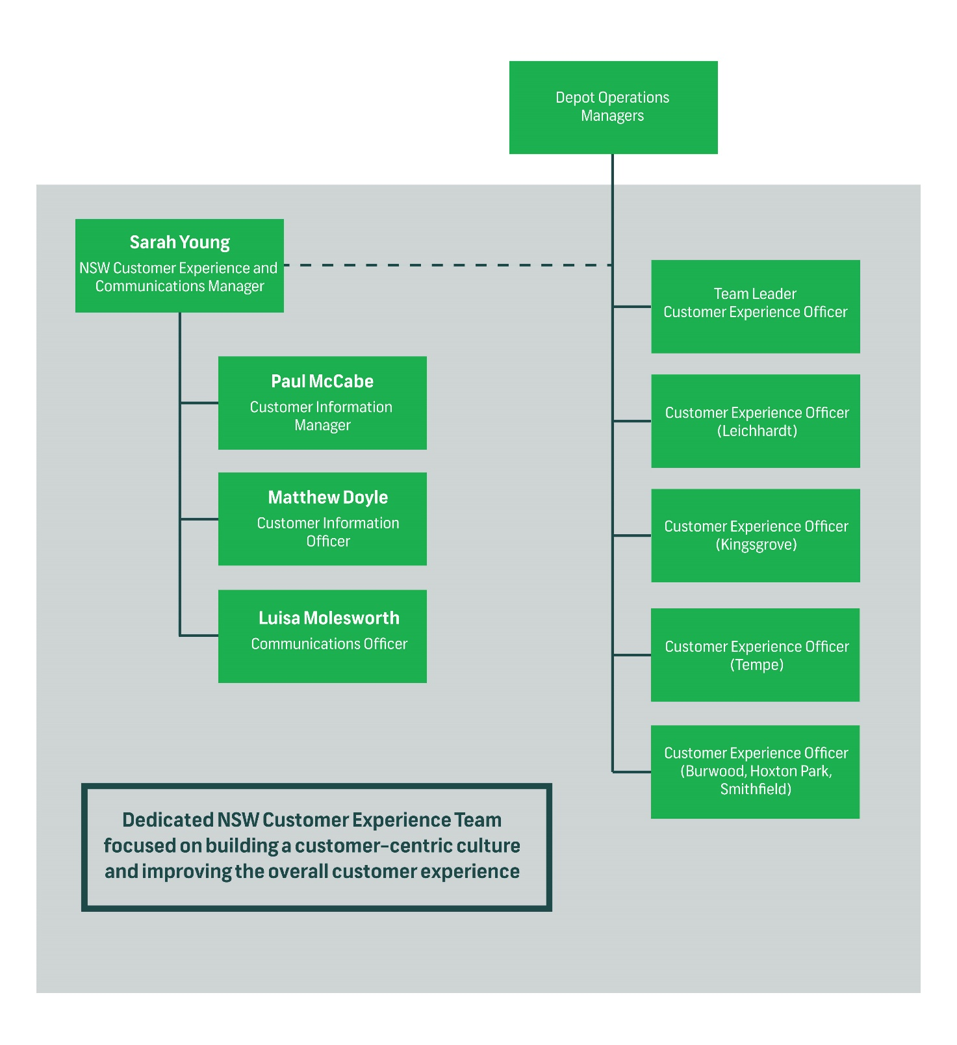

# Customer communication and interfaces throughout the journey during normal, degraded and planned service disruption operations

## Customer Communications Channels

We communicate with our customers through a variety of channels to ensure we reach the widest possible audience. These channels include online, at stop, and on bus options.

### Online Channels

Transit Systems NSW supplies data to Transport for NSW which feeds the TripPlanner and third-party real-time apps. This data is managed on a day-to-day basis using Transport for NSW operational real-time service management tool, PTIPS, to enter live information regarding cancellation or early termination of trips.

Service messaging is also provided to Transport for NSW to link to impacted routes for display during trip planning. Information is also included on the transportnsw.info website as the one-stop-shop for service-related information for customers.

### At stop channels

Customer information is displayed at the stop to communicate regular service information as well as notification of planned disruptions. At stop information consists of the bus stop sign (generally a shelter or b-pole), route information and maps, as well as timetable information for service utilising the stop. Newly installed b-poles also feature a braille panel to assist customers who are blind or have low vision identifying the stop number.

When planned disruptions occur, Service Change Notices are produced with stop-specific information displayed at the stop to advise customers of changed or alternative travel options.

### On bus channels

Passenger Information Displays are installed on all new buses purchased which provide next stop information in an audible and visual format to assist customers who are blind or have low vision, as well as passengers who are new or unfamiliar to the network. This system displays the route number, destination and next stops along the route path.

In addition, we have snapframes installed on the bulkhead behind the driver, providing an opportunity to place static posters onboard to advise customers of upcoming operational information, such as service changes or special events.

## Disruption messaging

It is not always possible to predict and plan for every event that may impact on service delivery. No matter how much planning is undertaken, there will be occasions when it proves impossible or impractical to operate all timetabled services.

Across the bus network, the most common unplanned events include high levels of traffic congestion, motor vehicle accidents, adverse weather conditions and disruptions to the wider transport network caused by impacts to infrastructure.

More significant (but less common) unplanned events include transport agency industrial action (rail, light rail, ferry, or bus), police operations, infrastructure incidents, and bus asset availability.

Recent times have demonstrated that incidents such as pandemics (e.g., COVID-19) present unique health and social restrictions that significantly disrupt public transport operations.

Planned disruption such as road works or special events can also have an impact on bus services.

### Planned disruptions and special events

Our Network Planning Team has dedicated staff who have well-established relationships with local councils, special event organisers, contractors, traffic management providers and other public transport operators and agencies. This allows us to be involved in the planning phase, aiming to achieve the best possible outcome for service diversions and minimising the impact to customers as much as possible.

##### OPERATIONAL RESPONSE

Our Operational Control Centre (OCC) is in regular contact with the Transport Management Centre (TMC), our On-Road Coordinators, drivers and Management team throughout the duration of the planned disruption or special event to monitor services and capacity across the network.

Our Network Planning Team is our first point of contact regarding temporary service changes and special events. Our Network Planners liaise with the parties involved, such as the TMC, other operational agencies, special event organisers, local councils, or construction companies, to create a transport Operational Plan that minimises the impact to our services and customers.

In the event of a major special event, where additional trips have been approved for operation, the Operational Plan is provided to our Scheduling Team who are responsible for scheduling the trips and creating the vehicle and crew schedules required to cater for the event.

If there are changes to the route structure due to road closures and diversions, the HASTUS Support team will plot the adjusted routes and produce the OSD data for TfNSW which feeds into static and real-time timetable information channels.

In the event that a planned disruption requires temporary bus stops to be established, we work with local stakeholders (including the TMC and Sydney Coordination Office (SCO) for major infrastructure projects) to determine suitable bus zone locations and develop customer information.

We have a dedicated team of On-Road Coordinators, who roam the network and can be deployed as needed to supervise operations during disruptions and special events.

##### COMMUNICATIONS RESPONSE

The **Customer Experience and Communications Team** (CXCT) are responsible for the preparation of bus stop notices, informing customers of the planned disruption, providing details of alternative travel arrangements, and removing the signage when the disruption ceases. This also includes provision of temporary bus stop signage when a stop is relocated due to a planned disruption.

The CXCT works with TfNSW and the TMC to push details of the disruption or event to trip planning tools, the Transport Info website and third-party apps. In addition, they work closely with the SCO and TfNSW to develop campaigns and signage for major special events, and where construction works are significant or have a major customer impact.

If the disruption is significant or lengthy, our HASTUS Support Team will produce and submit revised timetable and route data to TfNSW’s DCIS team so that customers can accurately plan their trip using the Transport Info website or an app.

In instances when a diversion is occurring long term, the CXCT will update route maps on [transportnsw.info](http://transportnsw.info/) to reflect the change to assist customers when planning their trip.

If a school service is significantly delayed or cancelled due to a disruption, our Operational Support Team will attempt to contact the school to inform them of the issue and provide details of alternative travel arrangements.

### Day of operation disruptions (unplanned disruptions)

We have a highly experienced OCC, staffed 24 hours-a-day, 7 days-a-week, which monitors the network and responds to incidents when they occur.

These include unplanned disruptions that impact bus services such as a burst water main, heavy traffic, vehicle accident or building damage. In these instances, a swift response and adjustment to services is critical to maintain reliability of our services and help reduce traffic in the impacted area.

Our OCC is in regular contact with the TMC to ensure a coordinated approach with other road and transport agencies.

For more significant and protracted disruptions, such as transport agency industrial action, police operations, infrastructure incidents or bus asset availability, the Managing Director NSW will take the lead and coordinate the response management.

During these unplanned disruptions it is critical that the Operations Management Team and the OCC effectively manage key corridors to provide the best possible customer experience.

##### OPERATIONAL RESPONSE

Our OCC is the first point of contact regarding unplanned disruptions to our bus services. The OCC will be notified by the TMC or via the drivers directly using the bus two-way radio. During periods of unplanned disruption, the OCC / TMC communication provides a crucial link between Transit Systems and TfNSW.

For disruptions that significantly impact the customers’ journey, our OCC will notify TMC so the situation can be jointly monitored.

Depending on severity and the anticipated duration of the unplanned disruption, our On-Road Coordinator will attend the scene of the incident, along with our Operational Management team. This supervision allows us to co-ordinate operations in the vicinity of the incident, provide assistance to customers, and deploy customer information at affected bus stops when necessary.

If required, our Operational Management Team will also disperse to key locations across the network to manage corridors and provide critical customer information.

Our OCC will adjust services to minimise disruption and maintain reliability of services for customers. This may mean temporarily diverting buses around the incident area or road closure and also managing available resources to ensure an even distribution of services across all key corridors.

##### COMMUNICATIONS RESPONSE

In the event of a disruption that affects the on-time running of a service, or requires diversion or suspension of a route, the OCC will promptly notify the TMC with full details of the issue. This notification allows TMC staff to push detailed disruption information to customer-facing information channels, including [transportnsw.info](http://transportnsw.info/), social media accounts, and third-party transport apps. The Transport Info contact centre is also informed of the issue via email, so that they can immediately address and resolve any customer queries they receive.

The OCC distributes SMS messages to Operational Management staff, so that they are aware of incidents and can rectify and allocate resources where warranted.

The use of two-way radios which are fitted to all our buses, allows our Drivers and the OCC to communicate with each other. This ensures that our Drivers receive regular updates of an unplanned disruption situation, and instructions on how to safely negotiate the incident location. Additionally, Drivers can relay issues they identify first-hand to the OCC.

Whenever possible, the OCC and Duty Officers will update the status of our bus trips in PTIPS to reflect how they are currently operating. This allows trip planning tools and third-party apps to show accurate real-time information for the affected services, so that customers are aware of the location and anticipated arrival time of their bus or if the service is unable to operate.

If the disruption will be lengthy, the OCC will prepare service disruption information for impacted bus stops, advising customers of any altered arrangements e.g., bus stop closures and the nearest alternative bus stop.

All disruptions involving critical incidents will be reported internally in accordance with the Serious Incident Response workflow.

# Customer and Staff safety and security

We are committed to creating a safe and healthy environment for our employees and customers. Our value of **‘**Safety Focused’ means we make safety a priority in everything we do. It’s the way we do business every day to provide an efficient, reliable, and safe experience.

Our safety commitments include:

* Communicating our safety commitment and performance.
* Promoting a strong safety culture by setting clearly defined responsibilities for managers, supervisors, employees, and contractors, to ensure everyone understands their responsibility for their own health and safety and the health and safety of others.
* Complying with legal obligations by ensuring our business is managed in accordance with relevant legislation, codes of practice, and standards.
* Ensuring appropriate resources are available to implement and maintain effective safety management systems.
* Ensuring meaningful and effective consultation with all relevant stakeholders with regards to continuously improving our safety management systems.
* Proactive risk management through the identification, elimination, control, and mitigation of risks.
* Providing a safe work environment using safe work practices and systems.
* Establishing coordinated safety plans with objectives and targets to monitor and measure performance.
* Providing appropriate training, instruction and supervision for all employees, contractors, and visitors.

## Safety Management System and Accreditations

Transit Systems NSW has a comprehensive Safety Management System which is embedded, functioning, and well understood in the business. The system helps to promote and provide a safe and healthy work environment. The Safety Management System is designed to manage the risks and hazards that come with operating public transport buses, bus depots, maintenance workshops, and administration offices, ensuring that plans and actions cater specifically to Transit Systems risk profile.

The Safety Management System has been developed and matured over time to meet the requirement of the following standards:

* AS/NZS 4801:2001 Occupational Health and Safety Management Systems (OHSMS)
* ISO 45001:2018 Occupational Health and Safety Management Systems
* ISO 14001:2004 Environmental Management Systems
* ISO 9001:2008 Quality Assurance Systems
* ISO 9001:2014 Asset Management

##### Passenger Transport Act 1990

Our Safety Management System meets all the criteria listed in the Passenger Transport Act 1990 by:

* Identifying significant risks that have or may arise from providing service,
* Specifying controls; including audits, hazard and risk identification process, putting in place the expertise, resources and employees to manage the identified hazards and risk,
* Monitoring and reviewing the safety outcomes in relation to the provision of services.

We continue to meet all requirements prescribed by the regulations and guidelines issued by Transport for NSW.

##### ROADS AND MARITIME SAFETY MANAGEMENT SYSTEM (RMS SMS)

Our SMS is underpinned by risk management and safety assurance processes. They are driven by organisational and leadership commitment through effectively implemented processes that address assets, people, and quality.

At the heart of the system - consultation, cooperation and coordination are integral to all elements of our SMS and aligns with Roads and Maritime Services SMS (RMS SMS) Handbook and the eight safety elements of:

* Commitment and objectives
* Management, accountabilities, responsibilities and communication
* Hazard and risk management
* Process documentation
* Transport safety employee monitoring program
* Training and education
* Safety performance measurement
* Audit and evaluation.

## Onboard safety and security systems

We have a number of systems on board our buses for the safety and security of our drivers and our customers. These include:

* **CCTV cameras –** all buses are fitted with CCTV cameras which capture every aspect of the bus, including a forward-facing camera, front door camera, driver camera and saloon cameras.
* **Two-way radio –** all buses are fitted with a two-way radio system which is monitored by our Operations Control Centre (OCC) 24 hours-a-day, 7 days-a-week. Our OCC is the first point of contact for drivers to receive emergency assistance in case of an incident while out on the road.
* **Emergency button –** all buses are fitted with an emergency button which when pressed, overrides all other communication on a particular radio channel to the OCC for an immediate response.
* **GreenRoad Driver Monitoring System –** all buses are fitted with a GreenRoad driver monitoring system which assesses driver performance based on safety and comfort.
* **Fire Suppression System –** all buses are fitted with an engine bay fire suppression system to minimise the risk in the event of a thermal incident. The Fire Suppression System works by alerting the driver of thermal activity in the engine bay area, while dispelling an environmentally friendly agent that cools down and chokes the fire, while also preventing the fire from reigniting. In an electric bus, fire suppression systems are installed in four areas of the bus: the rear electrical area, the near-side underfloor battery area, the off-side underfloor battery area, and the roof battery area.
* **Tyre Pressure Monitoring System –** all buses are fitted with a tyre pressure monitoring system which helps with early indication of thermal issues within the wheel arch. The system continually monitors the pressure and temperature of the tyres and alerts the driver via an indicator panel located in the driver’s cabin.

## Safety and Security Reporting Mechanisms

We have a number of systems in place to ensure our staff can easily report hazards and incidents for action. These include:

* **SafeConnect: ISO 45001 aligned software –** Transit Systems NSW has an app, SafeConnect, where employees can report hazards and incidents, track and document incident investigations, track actions and outcomes, and can be used for auditing purposes. The app is accessible via phone, computer or other mobile devices and helps to mobilise the workforce to strengthen our reporting culture.
* **Transport Security Incident Report Form –** Transit Systems NSW has a Transport Security Incident Report form that can be used to report any incidents on the road that are not life-threatening for example, incidents of graffiti or vandalism, repeat fare evasion, anti-social behaviour. This is then investigated by the operations team and actioned appropriately, such as reporting incidents to TfNSW for the targeted deployment of Transport Officers across the network.

# Event Services Support

When required, Transport for NSW requests us to provide buses when disruptions occur to train, bus, ferry, light rail, or Sydney Metro services. This occurs when these services are suspended to facilitate planned maintenance works, or unexpectedly when an incident or event requires the service be suspended or operate at a reduced capacity.

##### OPERATIONAL RESPONSE

For planned replacement services:

* In the event of planned disruptions to the broader transport network, Transit Systems will be advised by TfNSW or the Contracted Operator of the service specifications.
* Our dedicated Charters team, in conjunction with our Roster Clerks, manage the supply of buses and drivers to cover service requirements.
* Due to the fact that planned maintenance work can occur anywhere across the greater transport network, for example the Blue Mountains and Central Coast, and is scheduled to occur on weekends outside of our peak requirements, we plan our maintenance support accordingly. Our NSW Fleet and Facilities Manager ensures resources are available to respond to any issue promptly.

For unplanned/emergency replacement services:

* In the event of an unplanned disruption (for example equipment failure, a fatality, adverse weather conditions) the TMC will request the provision of emergency replacement buses at short notice.
* In the event of disruption that materially affects (or has the ability to materially affect) bus services, the Managing Director NSW will convene a meeting with the Senior Management Response Team to coordinate an appropriate and effective response.
* The respective Area Managers and depot Operations Managers will have responsibility for service delivery at each Depot and will work closely with On-Road Coordinators, OCC Controllers, Roster Clerks and Duty Coordinators to effectively manage services during periods of disruption.
* Our Depot Coordinators are responsible for allocating resources to assist using casual staff, voluntary overtime, or by altering existing shifts so that both the emergency and timetabled work is covered. This may involve temporarily reducing service frequency on some routes to redistribute resources where they will best meet broader community and transport needs.
* We have operational plans in place to ensure we can respond to emergency bussing requests promptly, including a register of predetermined trips that can be cancelled without significantly causing disruption to customers.
* Our OCC remains in regular contact with the TMC throughout the disruption to ensure services meet demand and are adjusted accordingly wherever possible.

##### COMMUNICATIONS RESPONSE

For planned replacement services:

* Route directional information can be accessed via the Road Manager portal, which is maintained by TMC.
* For planned and regular replacement services, our Customer Experience and Communications Team has developed a suite of Driver Guides that detail the operating instructions for the replacement routes, including essentials such as directions, maps and the station/stops/wharves each route serves. These are made available to staff on our intranet, and on the *Blink* employee app, and we continue to expand the collection as more routes are allocated to us to operate.
* If requested and whenever possible, our CXCT will program detailed destination signage for high profile or long-lasting replacement services. In addition, all our buses feature generic train, ferry, and light rail replacement destination signage to assist customers identify their bus.
* Our drivers are aware that trips may be altered by Marshals at key locations in order to meet demand and capacity requirements.

For unplanned/emergency replacement services:

* All our buses feature generic train, ferry and light rail replacement destination signage to assist customers identify their bus in the event of emergency replacement services.
* Our OCC remains in regular contact with the TMC throughout the disruption to ensure services meet demand and are adjusted accordingly wherever possible.
* Our drivers are aware that trips may be altered by Marshals at key locations in order to meet demand and capacity requirements.

# Ticketing, revenue protection and mitigation of fare evasion

Transit Systems NSW is committed to working closely with Transport for NSW to ensure ticketing information and requirements are communicated effectively to our customers, and appropriate revenue protection strategies are in place to help mitigate fare evasions. These strategies include:

* Increased reporting to Transport for NSW (weekly) identifying fare evasion ‘hot spots’ to ensure targeted deployment of revenue protection resources across the network. Locations are identified via driver and customer feedback and include at least two locations per depot.
* Regular internal communications campaigns targeting revenue protection strategies, including the safest ways to handle fare evaders and how to report fare evasion ‘hot spots’ to management.
* Work with Transport for NSW on an external campaign focusing on passenger fare compliance for promotion in snapframes and through Transport for NSW social media channels.
* Transit Systems staff attendance at key terminals providing a “Policing-style presence” to deter would be fare evaders.

# Operational integration with other public transport services

Transit Systems has built a reputation for its ability to work effectively with Government and other transport operators to provide innovative solutions and initiatives, with the goal of building a reliable and integrated transport network for Sydney.

While we operate under Contract with TfNSW, we understand the nature and the interconnectivity of the Sydney transport network, and the requirement of a flexible operational response. We are committed to assisting TfNSW and working collaboratively with the TMC and other transport operators to minimise disruptions and inconvenience to customers. This includes the timely notification of any significant disruptions or delays to our contracted services, to ensure the distribution of accurate travel information for customers through social media, websites and third-party apps when required.

# Customer feedback and lost property management

## Customer Feedback Management

We manage each customer feedback case individually to ensure any issues are rectified to avoid repeat complaints. The management of each case follows the process outlined below.

##### CUSTOMER FEEDBACK INVESTIGATION

Each depot has a dedicated Customer Experience Officer who investigates the case using numerous tools, including PTIPS (Public Transport Information Priority System), HASTUS (Scheduling software), TIMS (Human Resources database), Journals/Daily Allocation Sheet, Provide/Daily Variation Sheet and timetables. If there is insufficient information to investigate the case, the Customer Experience Officer will attempt to contact the customer (if contact details have been provided) to obtain further details regarding the case.

All investigation results are entered into the Salesforce system and relevant documentation is attached to the case for future reference. If further action is required to resolve the matter, such as driver interviews or downloading of CCTV footage, this is also noted for the Depot Supervisor, 2IC or Performance Management Officer to action.

##### CUSTOMER FEEDBACK RESPONSE

If the customer has requested a response, the Customer Experience Officer will contact the customer by their preferred means requested in the case details i.e., by phone, email, or letter. Emails are sent directly from within the Salesforce system and are automatically logged on the case as evidence of contact with the customer. If the customer has requested a return phone call, all details of the conversation are logged on the case, including the date and time of call and the outcome of the conversation.

##### CUSTOMER FEEDBACK RESOLUTION

Once the case has been resolved with the customer, the Customer Experience Officer will change the status of the case to ‘Closed’ if no further action is required, or ‘Closed with Customer’ if further action is required to resolve the feedback issue. If further action is required, such as an interview with a driver or for CCTV footage to be downloaded from the bus, the case will move to a ‘work in progress’ queue (WIP). Any further information obtained, and actions taken are added to the investigation details of the case to ensure we ‘close the loop’ regarding the feedback provided.

##### COMMENDATIONS

As we manage our customer complaints and feedback, we also thoroughly investigate and reward our staff who receive compliments from our customers for going the extra mile. When a compliment is received in the Salesforce system, this case is investigated by our Customer Experience Officers to identify the staff member involved and confirm the feedback. This information is passed on to our Operations team who prepare a certificate of commendation for the staff member along with a letter from their manager including the original customer verbatim received, minus any identifying information regarding the customer.

##### REPORTING AND KEY PERFORMANCE INDICATORS

Numerous reports have been built in the Salesforce system to allow complaint data to be fed back into the business. Examples include complaints per route, complaints per issue and complaints by employee. These are also shown in purpose-built dashboards within the Salesforce system. This helps us identify trends and target our response to areas where improvement is needed most and helps us achieve accurate KPI reporting.

## Lost Property Management

We ensure that every reasonable effort is made to reunite owners with property left on our buses and have detailed processes in place for the management of Lost Property items. We have a formal lost property Operations Instruction, A1001 Lost Property, which clearly details the processes that must be followed with all lost property located on our buses. This includes the processes that must be followed when:

* Receiving lost property
* Storing lost property
* Responding to lost property enquiries
* Disposing of lost property, including:
  + returning to the owner
  + donating the item to a licensed charitable organisation
  + destroying the item
  + discarding the item
  + returning property to interstate owners
  + valuable items such as mobile phones, money, foreign money
* Handling dangerous goods or prohibited items
* Handling perishable goods
* Managing lost property records
* Handling instances of missing property

A summary of our lost property process is outlined below.

##### CONTACTING US

Our contact details are shown on our website – [transitsystems.com.au](http://transitsystems.com.au/) – as well as all major internet search engines, the Transport Info website ([transportnsw.info](http://transportnsw.info/)) and Service NSW ([service.nsw.gov.au](http://service.nsw.gov.au/)).

Customers can contact us in person or by telephone during office hours - 8am until 4pm, weekdays.

Outside of office hours we will have a voicemail service allowing customers to leave details of the item they have lost and their contact number. The voicemail service is checked by our administration staff the following business day. We can also be contacted by email.

##### ENQUIRIES

When a customer contacts us to enquire about an item that they have misplaced, the item is initially searched for at the depot where the contact was made using our Lost Property System.

If the item has been lost on a route operated by another depot, or on a route operated by multiple depots, our administration staff promptly contacts the relevant location/s to perform a search.

##### RECEIVING LOST PROPERTY

When our staff find Lost Property, they hand the item to our administration staff (or Duty Officer outside of office hours) and provide details regarding where and when it was found.

The item is registered into our Lost Property System (the TfNSW Lost Property System), and a unique reference number is assigned to it. It is then labelled with this reference number, and the date when it was found.

We abide by the Impounding Act 1993 with regards to the collection, storage and release of all Lost Property items. We also recommend that our staff use relevant Protective Personal Equipment when handling Lost Property to protect themselves from potential injury.

##### STORAGE AND HANDLING OF LOST PROPERTY

All Lost Property items are held for 30 days. Where practicable, perishable items are stored in a safe manner for 24 hours to ensure that they are not spoiled.

We ensure that all Lost Property items are stored in a secure location, with high value items such as money and jewellery placed in a locked storage facility. Any money we find in wallets is counted by our administration staff, verified, and noted. The money is kept in the wallet and stored securely.

##### RETURNING LOST PROPERTY TO CUSTOMERS

When a customer enquires about items we have found, we inform them of the location where it can be claimed, and request they show suitable identification when collecting it. The item is returned to the customer by our administration staff.

If we notice owner details when we register the item, we will attempt to contact the customer and advise them that we have found their property.

If the item cannot be located on the Lost Property System, the owner is advised and asked to enquire again later. If the item has only recently been lost and is of high value, we make a practicable attempt to locate it by contacting a specific bus or buses by two-way radio.

As Lost Property records may contain personal information, we ensure that they are stored in a manner that protects the individual’s privacy.

##### DISPOSAL OF UNCLAIMED ITEMS

When disposing of unclaimed items, we abide by the legal requirements outlined in the Impounding Act 1993.

When we are unable to identify the owner of Lost Property, or it is not collected by a customer, we donate it to a licensed charitable organisation after a minimum period of 30 days. If the item is of low value and not wanted by the charitable organisation, it is disposed of.

Any used mobile telephone which is not claimed after a minimum period of 30 days is sent by us to an Authorised Third-Party Recycler.

Money that has been stored and not claimed after 30 days is donated by us to a nominated Charitable organisation. Any foreign notes and coins are donated to UNICEF.

Prohibited items such as firearms, drugs and weapons are referred to NSW Police. The disposal of dangerous goods, such as fuel, biological wastes and solvent-based items, is coordinated with our Workshop Manager to ensure it is done safely.

Perishable goods not claimed within 24 hours of being found may be discarded.

All uncollected items are disposed of or destroyed in a manner that protects the privacy of the owner.

# Customer Service Training and Development of staff

From the mechanics who ensure our fleet runs smoothly to our drivers, operational support employees and cleaning crew, all employees are required to undertake our customer service training – the Brilliant Customer Service Program. This training is a new enhanced program that will be delivered across a variety of channels and will be complemented by regular internal communications campaigns and material reinforcing our expectations, associated behaviours, and company values.

We understand that the job of operating contract bus regions for TfNSW is bigger than just operating a bus service. We will ensure our team is equipped with the tools and training to provide exceptional service, understanding, and sensitivity under any circumstance.

## Online Training Module – Customer Service (Including Disability Awareness)

Online customer service training will be provided to our drivers and support employees with clear guidance on expectations, standards, and values.

All employees are required to complete our 1.5-hour online training module on Customer Service and Disability Awareness. New employees will be required to complete this as part of their online induction before they commence their first day on the job. All employees will be required to complete it as a refresher annually.

Our online training module covers:

* Our customer service principles and expectations
* Customer journey familiarisation and relevant touch points
* The different types of customers that travel on our services
* Tactics to turn a potentially negative experience into a positive one
* Disability awareness and how to assist customers with special needs
* Relevant legislative requirements and expectations of us, as a public transport provider.

## Brilliant Customer Service Program

A new digital training module is currently being developed to support the broader workforce deliver in the Kelsian Group’s COMPASS Values, with a key focus on enabling employees to bring to life the Customer Focused Value – We focus on delivering a brilliant experience for every customer. This training module, titled the Brilliant Customer Service program, has been developed with a top-down approach to ensure brilliant customer service is delivered at all levels of our business.

The new program delivery commenced in mid-2022 with the training of our management team, with all other frontline and support staff due to receive training in FY23-24. The training will be delivered to every employee at Transit Systems, providing customer service training content specific to the position performed. This training will also be incorporated into the induction training package for new employees, setting the expectations for professionalism and customer service of Transit Systems and the broader Kelsian Group.

## Classroom Induction Training

Before a driver is on the road, all employees undertake face-to-face classroom-based induction training which complements the online training modules completed prior to commencing their employment with us.

Our classroom-based induction training includes a 1.5-hour module focused on customer service and Disability Awareness, covering our expectations and the requirements of our employees in greater detail. Refresher training is also carried out annually for all employees. Topics covered in the training include:

* Knowing the types of customers who use our services
* Customers with special needs, including senior customers, parents/carers travelling with children in prams or strollers, customers with a disability and their carers
* Carriage of goods and animals, including assistance animal requirements
* School children and operating school special services
* Tourists/visitors to Sydney
* Customer diversity and anti-discrimination legislation
* Dealing with difficult customers and customer complaints.

Training emphasises ensuring all customers are treated fairly, equally, with respect and sensitivity, regardless of race, cultural background, special needs, abilities, gender, sexual preference or age.

## Driver Guidelines Handbook

All frontline employees are issued with a Driver Guidelines Handbook which emphasises customer service, particularly with assisting customers with special needs. The below table lists included topics.

|  |  |
| --- | --- |
| **Driver Guidelines Handbook Customer Service Topics** | |
| **Customer Service** | Having a positive attitude |
| Safe, smooth driving |
| Customer safety when boarding and alighting |
| Courtesy to other road users |
| Dealing with difficult customers |
| **Customers with special needs** | Wheelchair accessibility |
| Customers with vision impairment |
| Animals on board |
| Parents/carers with prams |
| Mobility scooters |
| Other disabilities (that are not obvious) |
| **School services** | School children |
| Fares and boarding |
| School warning or ‘wig wag’ lights |
| Operating school services |

## Customer Service Campaigns and Messaging

Customer service messaging doesn’t just stop with formal training. Regular Customer Service Campaigns and messaging will be distributed to our employees across our internal communications channels, to provide micro-learning opportunities, including:

* Regular customer service monthly focus campaigns
* Interviews with our customers who have a disability
* Celebrating excellent customer service through employee recognition
* Promoting customer sentiment across the business
* Micro-learning opportunities via our employee app.

## Cultural Competency Training

All our Senior Management Team has participated in Cultural Competency Training, conducted by Arrilla Connect. This training was carried out to ensure the work we do moving forward to increase diversity and inclusion in our workforce is not only effective, but also sensitive to Aboriginal and Torres Strait Islander peoples and cultures. The training was well received by our senior managers, and we are currently investigating rolling this training out to our wider NSW workforce.

## Other Initiatives

|  |  |
| --- | --- |
| **Initiative** | Description |
| **Monthly Focus Campaigns – internal customer service** | Monthly Focus campaigns target customer service in the business. These campaigns highlight to our employees that not all our customers travel on buses and identify different internal customer groups for each employee or team, from our Managing Director down. We know interactions with a colleague or supervisor at the start of the day can influence the mood of our employees for the rest of their shift. By promoting a customer-focused and positive mindset for all interpersonal interactions within the workplace, we anticipate this mindset and positive attitude will filter through to our customer interactions out on our network. |
| **Review and refresh of online training material** | To align with the broader Kelsian Group and create one central online training platform across the business, Transit Systems NSW has moved our online training from ELMO to the GO1 Learning Management System. Switching our online learning platform provides an excellent opportunity to review and refresh our training material to ensure it is engaging and informative for our employees. As part of this review, we will be looking for new ways to promote a customer-focused culture within our business and incorporate new customer service campaigns that have been delivered since our training portal was established. |
| **Review and refresh of classroom-based training material** | In line with our review of online training material, our restructured training department will work closely with our Customer Experience and Communications team to review and refresh all classroom-based training materials to ensure it aligns with our broader company messaging regarding customer service. This provides an opportunity to ensure the material is fresh and engaging and sets the right tone for new employees to our business. |
| **Establishing partnerships with Disability Support and Advocacy Groups** | We are committed to establishing partnerships with key disability groups, such as Guide Dogs NSW/ACT, Spinal Cord Injuries Australia, Indigenous Disability Advocacy Service, to help build empathy and awareness of customers with disabilities and to provide guidance with training requirements to ensure the content is relevant and engages the community of people with disabilities. |
| **Corporate Social Responsibility Framework** | The five pillars of our Corporate Social Responsibility Framework (CSR), Moving Forward, are Diversity, Reconciliation, Sustainability, Community and Team. Moving Forward guides our organisation to actively make a positive impact with our communities by providing a safe and satisfying workplace, contributing to a healthier environment, celebrating diversity and acknowledging reconciliation. |

# Measures and strategies

Transit Systems will use the following measures to ensure continuous improvement to service delivery and overall customer experience:

* **Mystery Shopper Program –** Transit Systems NSW will deploy Mystery Shoppers across the network (~100 trips per contract region per month) to track customer satisfaction across all aspects of the customer journey – from the time they plan their trip using real-time apps and TripPlanner, to their experience at the stop with regards to stop infrastructure and information, the presentation of the fleet, friendliness of the driver and safety and reliability of services. Any issues identified are investigated and appropriate action taken to rectify the issue.
* **Customer Complaint Data –** Transit Systems NSW will analyse customer complaint data to identify trends for rectification and track improvements across our contract operating regions.
* **Transport for NSW Customer Satisfaction Survey –** Transit Systems NSW will track the results of Transport for NSW’s Customer Satisfaction Surveys to identify areas for improvement. Our aim is to see continuous increases in customer satisfaction in all areas within our control, so that we meet and/or exceed our contract targets.

# Equitable access for all customers

Transit Systems NSW is committed to delivering reliable, safe, and accessible public transport services for everyone in the community. We understand that many of our customers depend on our services to live independently and include people with a disability, the elderly or those with limited mobility, as well as people from linguistically and culturally diverse backgrounds. To ensure equitable access to both our services and our information, we have developed an Accessible Transport Action Plan, which can be found on our website – [www.transitsystems.com.au](http://www.transitsystems.com.au)

This plan provides guidance on how Transit Systems NSW will provide an environment that is accessible for all customers and employees, where practicable, and ensure we continually evolve to meet changing customer needs.